COMP 0560: Artificial Intelligence I
Final Exam
Spring 1999

Chapter 1: Introduction to AI

- [10pts] In the textbook, the authors discuss 4 approaches for (in defining) Artificial Intelligence. List and briefly describe them?

- [10pts] What is the Turing test? List 6 areas of AI that are needed in order to allow a machine to pass this test.

- [5pts] What is the primary difference between symbolic and subsymbolic approaches to AI? Of these two approaches, which do you think is more effective? Explain your answer.

COMP 0560: Artificial Intelligence I
Final Exam
Spring 1999

Chapter 2: Agents

- [10pts] Agent = __________ + ___________.

- [10pts] Explain the relationship between ideal mappings and ideal rational agents?

COMP 0560: Artificial Intelligence I
Final Exam
Spring 1999

Chapter 3: Uniformed Search

- [10pts] Using the Figure below, what order will the nodes be visited using (a) iterative deepening, (b) uniform-cost search.

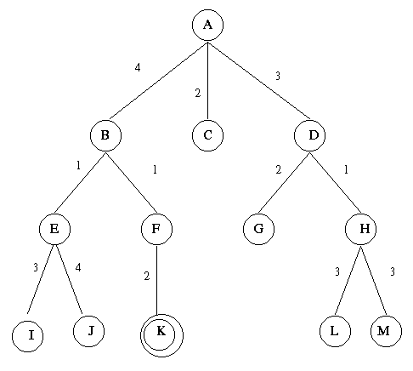

COMP 0560: Artificial Intelligence I
Final Exam
Spring 1999

Chapter 4: Informed Search

- [5pts] (True or False) All A* algorithms use monotone heuristics.

- [10pts] According to the textbook, what type of A* algorithm would work best with an ∈-admissible heuristic? Why?

- [5pts] What is the effective branching factor of a heuristic? How can it be used to determine if one heuristic is more informed than another?

COMP 0560: Artificial Intelligence I
Final Exam
Spring 1999

Chapter 5: Game Playing

- [10pts] Using the two-ply game tree below. Show what MAX’s best first move would be using Alpha-Beta pruning. Make sure that you identify which edges are to alpha/beta pruned.

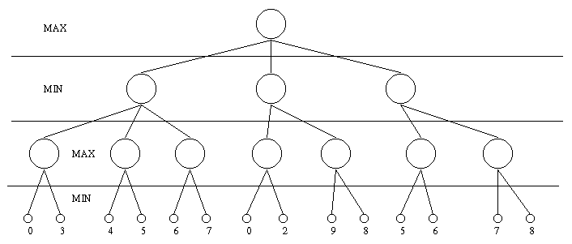

COMP 0560: Artificial Intelligence I
Final Exam
Spring 1999

Chapters 6,7,9: Propositional & First Order Logic

- [5pts] Explain why p(f(x,x),A) does not unify with p(f(y,f(y,A)),A).

- [10pts] Convert the following sentences into first-order logic and use resolution refutation (along with Green’s Theorem) to find out: Who is a member of the Sierra Club who is a mountain climber but not a skier?

Jim, Dave, and Ted belong to the Sierra Club. Every member of the Sierra Club is either a skier or a mountain climber or both. No mountain climber likes rain, and all skiers like snow. Dave dislikes whatever Jim likes and likes whatever Jim dislikes. Jim likes rain and snow.

COMP 0560: Artificial Intelligence I
Final Exam
Spring 1999
.

Chapter 18: Learning from Observations

- [5pts] List the 4 conceptual components of a learning agent.

- [10pts] Inductive Learning searches a ______________ hypothesis space ___________, while Candidate Elimination searches a __________________ hypothesis space _____________________.

Introduction to Genetic & Swarm Intelligence

- [10pts] What is difference between hill-climbing and simulated annealing?

- [10pts] Explain the differences between Genetic Search and Particle Swarm Optimization.

- [10pts] List and describe the six properties of swarm intelligence.

COMP 0560: Artificial Intelligence I
Final Exam
Spring 1999

COMP 0560: Artificial Intelligence I
Final Exam
Spring 1999

COMP 0560: Artificial Intelligence I
Final Exam
Spring 1999

